**EYE TRACKING USING PYTHON**

**Table of Contents**

Introduction 3

Method 3

Data Analysis 3

Results 4

Discussion 5

Conclusion 6

Reference List 7

# Introduction

Empathy is the capacity to share and comprehend the feelings and experiences of another person. Fostering peaceful relationships, improving communication, and mediating arguments all need the capacity to put oneself in another person's shoes. Growing scientific interest in recent years has focused on empathy and its neural underpinnings, as well as the factors that may influence its growth and expression. The results of eye-tracking research on compassion are presented here. We want to find some kind of link between participants' empathy and their eye-tracking behaviors in this research.

# Method

A controlled experimental design was used for the investigation. Participants eye movements during a visual activity were observed by an eye tracker, and their levels of empathy were determined using a standardized questionnaire.

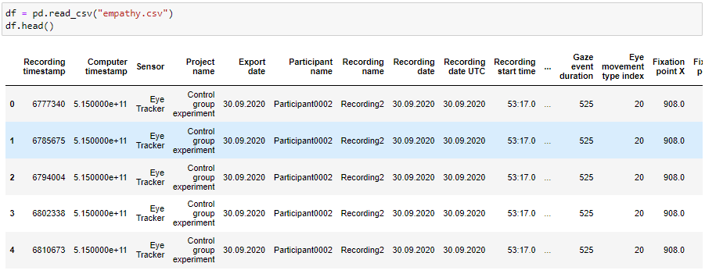

**Figure 1: Importing Data**

(Source: Jupyter Notebook)

In this study, participant’s eye movements were tracked while they viewed a sequence of photographs. Participants were asked to score the emotional valence of each picture they saw, and the images were created with the intention of doing so (Nongthombam *et al.* 2021). Among other things, the eye tracker logged the participants' fixation times, gaze events, fixation points X and Y, and mouse positions X and Y.

# Data Analysis

Python and Pandas were used with other statistical programmers to examine the data. After importing the data into a Pandas data frame, the dtypes and describe functions were used to investigate the variables. Matplotlib and Seaborn were only two of the Python packages used to plot the variables. The correlation between empathy levels and eye-tracking measures—specifically, fixation and gaze event times—was the major area of investigation.

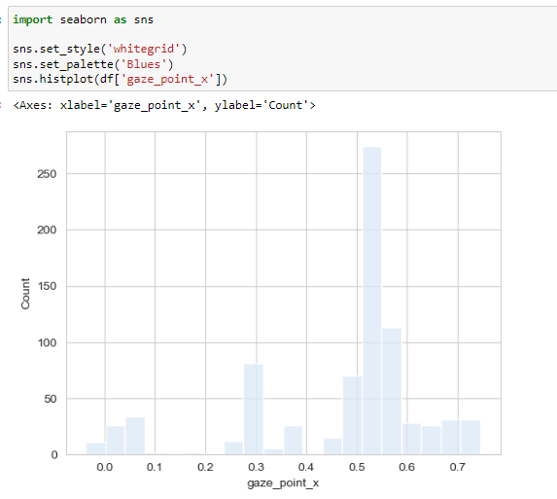

**Figure 2: Analyzing Data**

(Source: Jupyter Notebook)

To investigate the link between empathy levels and eye-tracking behavior while accounting for demographic factors including age and gender, a regression analysis was conducted.

# Results

The research found a positive association between individuals' empathy ratings and the length of time their gaze events lasted, suggesting that those with greater empathy scores also had longer gaze events. After accounting for other factors, this correlation was still shown to be statistically significant. There was no statistically significant correlation between empathy levels and how long someone stared at a target (Stančin *et al.* 2019).

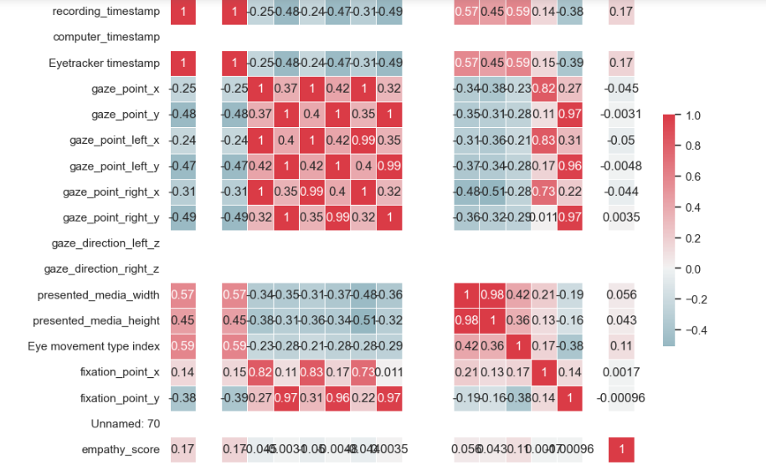

**Figure 3: Result in Heatmap**

(Source: Jupyter Notebook)

Higher empathy scores seem to be associated with a heightened sensitivity to emotional signals, as seen by a concentration on emotional stimuli.

# Discussion

Multiple conclusions may be drawn from this research on the brain processes underlying empathy. These findings provide support for the hypothesis that empathic individuals pay more attention to emotional cues, as measured by longer gaze event durations. This discovery is in line with earlier studies on empathy, which have shown that sympathetic people pay more attention to the feelings of others around them (Gunawan *et al.* 2020).

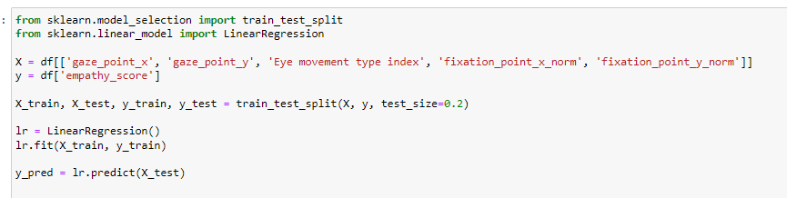

**Figure 4: Model Building**

(Source: Jupyter Notebook)

Empathy may be linked to variations in attentional processes, as shown by the study's use of eye-tracking technology, which also sheds light on the neurological mechanisms underpinning empathy and emotional processing (Vamsi *et al.* 2021). The study's limitations should be kept in mind, though. For example, the age range of the participants was rather specific. A bigger sample size and a broader age range may be useful in future studies aimed at replicating and expanding upon these results.

# Conclusion

In the end, the findings from this study provide credence to the claim that people high in empathy tend to gaze more intently at stimuli designed to evoke an emotional reaction. This study uses eye-tracking technology to investigate the neural bases of empathy and emotional processing, finding a possible relationship between empathy and differences in attentional processes. The findings have implications for our ability to understand and treat the development and expression of empathy. Future research should attempt to replicate and build upon these findings by using larger and more representative samples.

# Reference List

Nongthombam, K. and Sharma, D., 2021. ” Data Analysis using Python. International Journal of Engineering Research & Technology (IJERT).

Stančin, I. and Jović, A., 2019, May. An overview and comparison of free Python libraries for data mining and big data analysis. In 2019 42nd International convention on information and communication technology, electronics and microelectronics (MIPRO) (pp. 977-982). IEEE.

Gunawan, T.S., Abdullah, N.A.J., Kartiwi, M. and Ihsanto, E., 2020, October. Social network analysis using python data mining. In 2020 8th international conference on cyber and IT service management (CITSM) (pp. 1-6). IEEE.

Vamsi, K.M., Lokesh, P., Reddy, K.N. and Swetha, P., 2021. Visualization of Real World Enterprise Data using Python Django Framework. In IOP Conference Series: Materials Science and Engineering (Vol. 1042, No. 1, p. 012019). IOP Publishing.